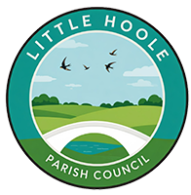
LITTLE HOOLE PARISH COUNCIL (LHPC)
Summer Activity Programme 2026
🎉 FREE FAMILY FUN! 🎉
Dob Lane Recreation Ground
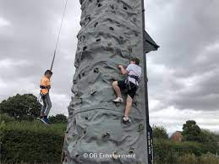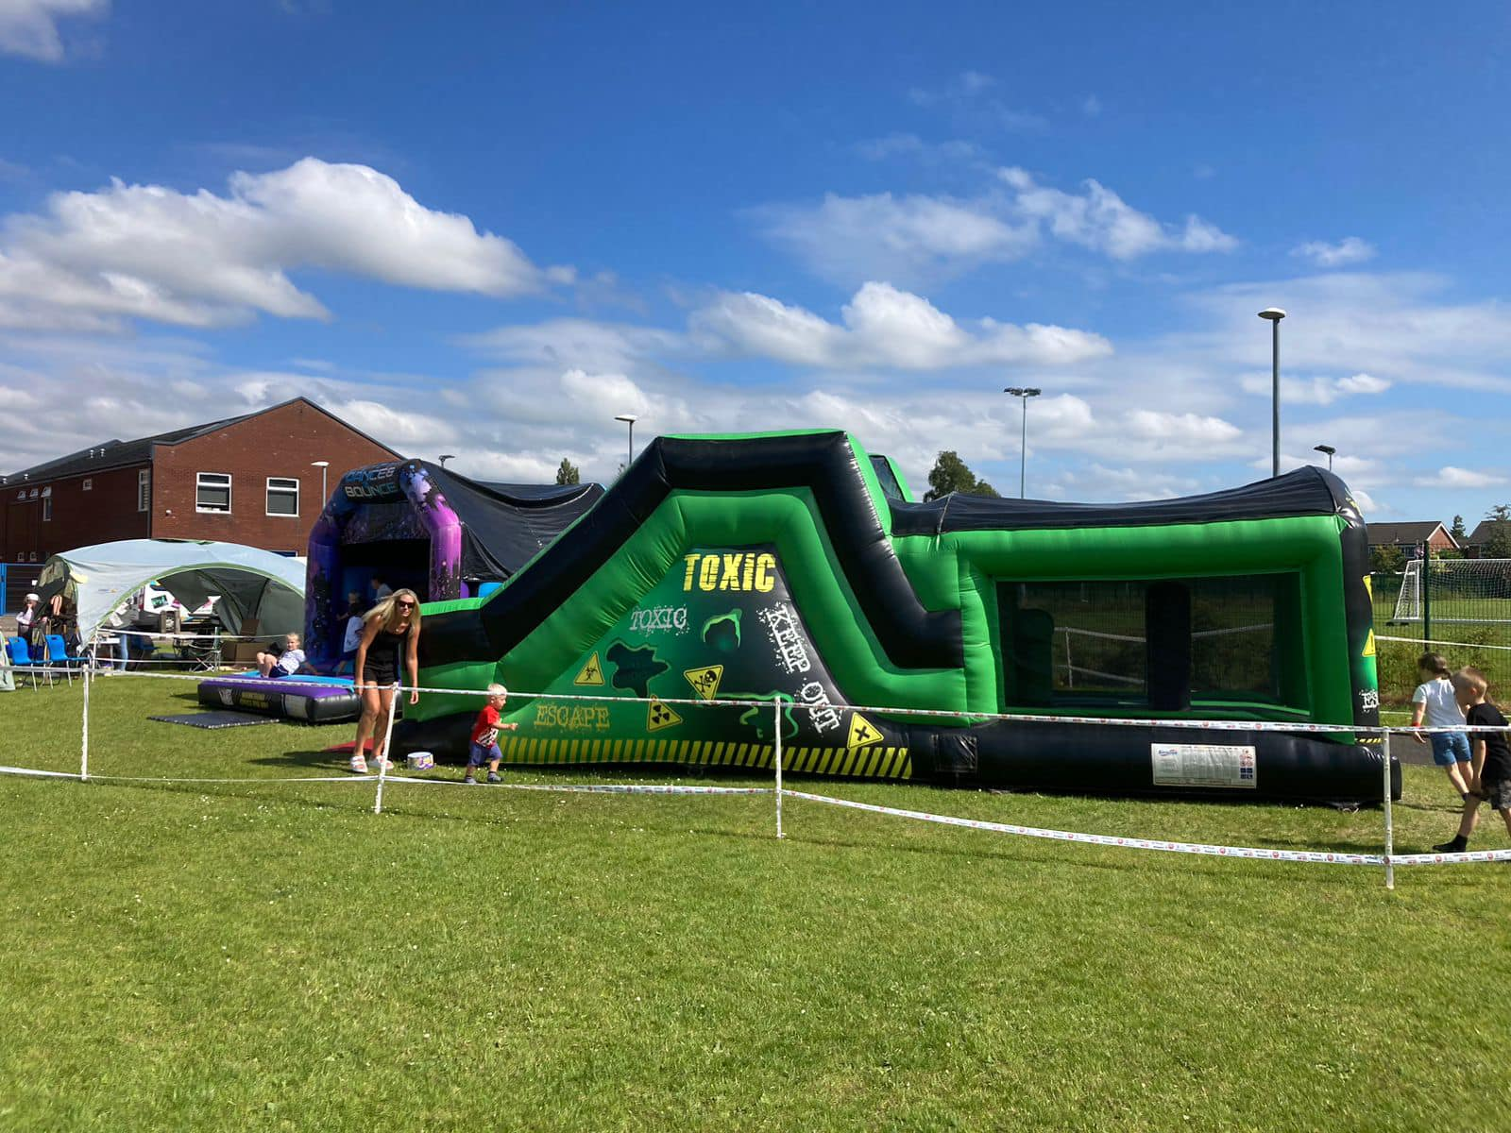

A super inflatable slide, Toxic obstacle course and a Climbing Wall will be available on the following Thursdays in July & August between 10am – 3pm:
23 July – 30 July - 6 August - 13 August - 20 August – 27 August
✅ IMPORTANT - All Children must be accompanied & supervised by an adult
⭐ 100% FREE – NO BOOKING NEEDED! ⭐
Funded by Little Hoole Parish Council

