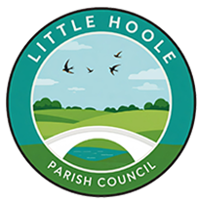**Walmer Bridge Community Orchard**

Little Hoole Parish Council in Partnership with Lancashire County Council have received funding to create a Community Orchard in Dob Lane Park.

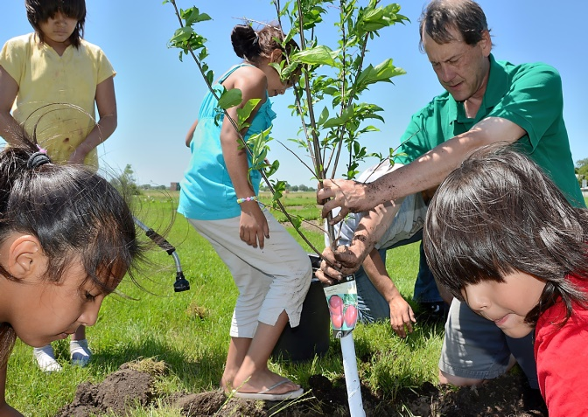

The Parish Council would like to invite children and their families to come along and help plant our new fruit trees

**When – Saturday 5th April 10:30 – 12:30**

**Where – Dob Lane Recreation Ground**

**Just bring clothes to suit the weather, and if you have them, some gloves**

**Little Hoole Parish Council will provide refreshments**

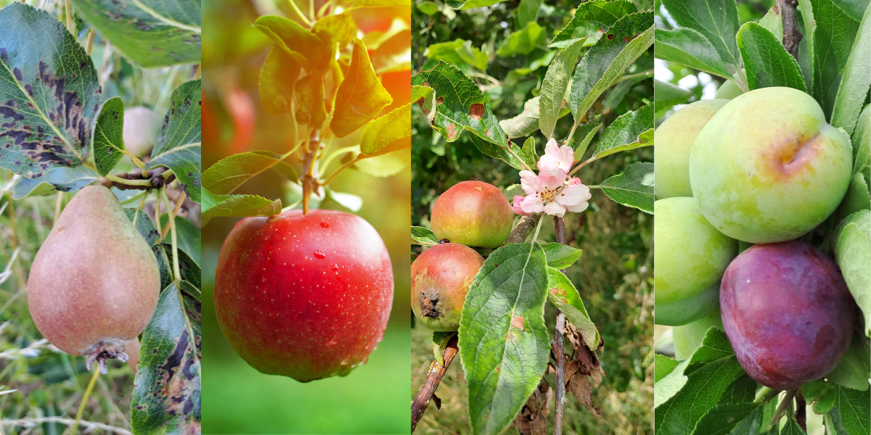

<https://www.littlehooleparishcouncil.org.uk>