**Dob Lane Digs Deep: Community Unites to Plant New Orchard**

*Little Hoole, South Ribble – April 2025*

Dob Lane Recreation Park got a fresh new look this month, and no, it wasn’t just the spring sunshine. Locals turned out in wellies and gloves, spades in hand, for the planting of a brand-new community orchard—bringing a whole new meaning to the phrase *fruitful collaboration*.

On the 5th of April, families from across the community gathered on the park’s grassy stretch to meet with Ian Wright from Lancashire County Council (LCC), who led the planting of 12 young fruit trees. The day was part of a wider LCC tree-planting scheme being rolled out in 2025, which includes the creation of micro forests, orchards, and the introduction of many more trees across the county.A child holding a shovel in a field

This particular orchard was the result of a joint effort between Lancashire County Council, South Ribble Borough Council, Little Hoole Parish Council and local residents. Around ten families showed up, children in tow, all ready to get their hands dirty and be part of something that will grow with the community.

Each tree was given the VIP treatment—planted with rich compost and nitrous pellets to give them a strong start, tied securely to wooden poles, and fitted with protective stem covers to keep hungry rodents at bay. And a special shoutout goes to Gabriel and Kit, who took on the important task of watering the trees using buckets filled straight from the nearby brook.

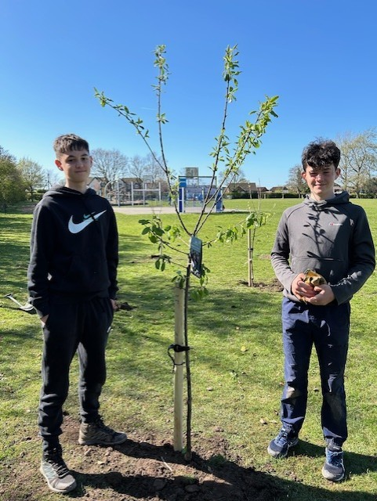

“It’s been such a lovely day,” said one local mum, beaming as her kids admired the freshly planted saplings. “It’s great to do something positive as a family and know we’re contributing to something that’ll grow for years to come—literally!”

Representatives from all three levels of government pitched in. “This is a perfect example of community and council collaboration,” said one Parish Councillor, brushing soil off their hands. “We’re planting more than trees—we’re planting a legacy.”

The orchard is set to become a haven not just for people, but for pollinators and wildlife too.

So next time you're walking through Dob Lane Rec, keep an eye out for the row of young trees now standing proud near the bottom of the park. They’re more than just saplings—they’re a sign of what can grow when a community comes together.

Thanks to:  
Parish Councillor Tanya Wilcock for organising the planting of the Orchard;  
Parish Councillor Sara Evald for the photos;  
Lancashire County Council for the funding;  
South Ribble Borough Council for the use of the Park; and  
most importantly members of the local community for turning out to help plant the trees.

