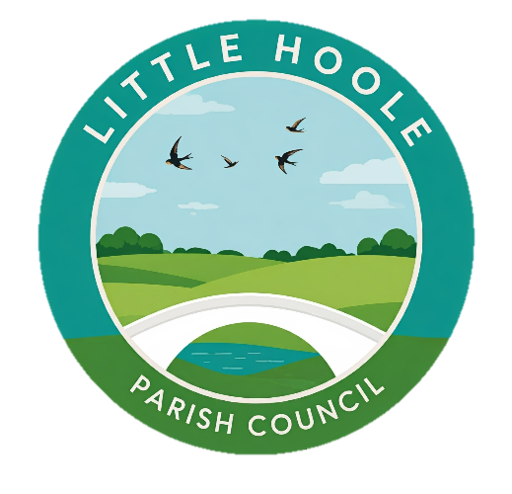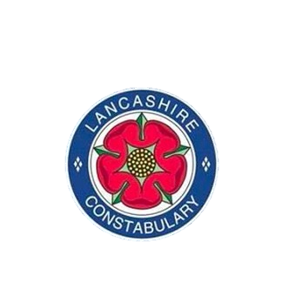
Little Hoole Parish Council and Lancashire Police
would like to invite you to attend a meeting with our local police officers.

The meeting is being held at
Walmer Bridge Village Hall
Tuesday the 18th of November 2025
19.15 – 20.45

Some of the issues we will discuss are:
Speeding in the village
Threatening cold callers
Antisocial behaviour
Cybercrime
Road safety
We invite you to ask questions or raise concerns on the night.
If you are unable to attend but want to ask a question, please email the parish council clerk@littlehoole-pc.gov.uk

